

DATA STRUCTURES FINAL PROJECT

Application of the Graph ADT for path planning in a road network



Verissa owusu

**Introduction**

This paper focuses on using the graph data structures to model the Ashesi University road network. Graphs are used to represent the relationships between pairs of objects. The objects are called vertices and the relationships between the pairs are called edges. This project seeks to model all the various paths in moving around the Ashesi campus from the security checkpoint up to the library and considering the Engineering building and the Research building. The aim of this project is to enable efficient path planning methods for the tour guide directors when handling different groups of visitors. Thus, the project seeks to plan paths based on scenic views and tour duration factors. This project can assist the Ashesi Tour guide team in carrying out tour programs for visitors to the school.

**Background**

“Graphs (sometimes referred to as networks) offer a way of expressing relationships between pairs of items, and are one of the most important abstractions in computer science” (“Graphs: Deﬁnition,Applications, Representation”) . there are two types of graphs, directed and undirected graphs. Directed graphs represent asymmetric relationships while undirected graphs represent symmetric relationships. Some key terms in the Graph ADT are neighbours, neighbourhood, paths, degrees, cycles among many others.

Graphs can be applied in social networking platforms, network packet traffic graphs and many others.

**Approach**

To map out the system for the road network, first must get a pictorial view of the road network in Ashesi University. In this diagram there is a representation of all the significant buildings and the paths that lead there or can be taken to get there and how they connect to other buildings. Since the university campus is large, this project focuses on the lower level of the campus from the Security checkpoint to the path in front of the King Engineering building, Research building and Akorno and the path also moving from the Security checkpoint to the Sports centre. The area focused on is represented in Figure 1 below.

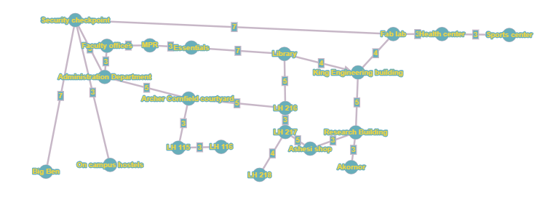

Figure

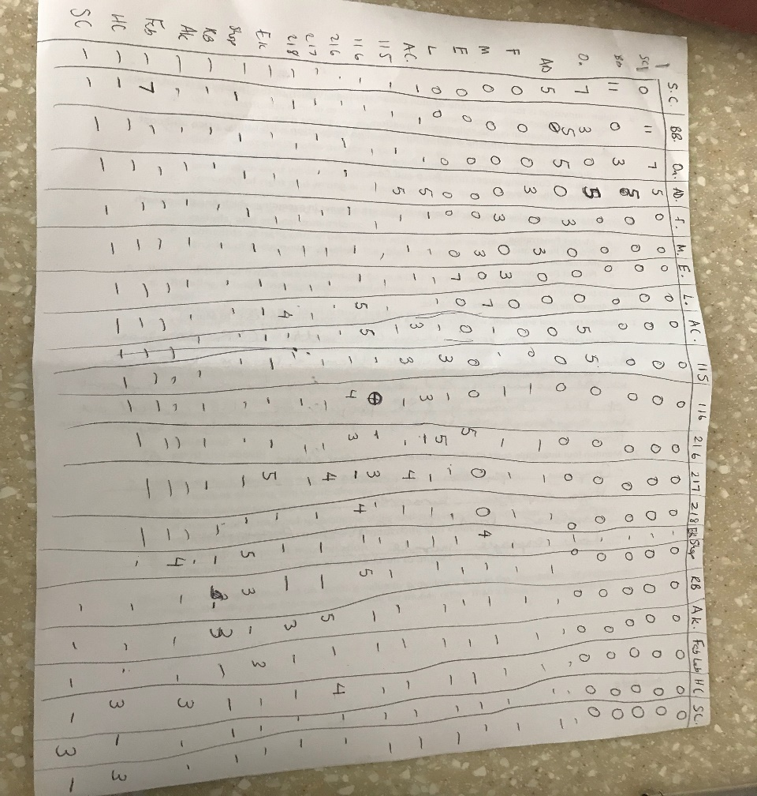In doing so, an adjacency matrix which is a two-dimensional array, had to be implemented to show the various time durations of the paths available. The adjacency matrix has N * N size where N is the number of nodes or vertices in the graph. The adjacency matrix also shows the weight of a graph, in this case the weight will refer to the duration of time used to move from one location to another using the paths represented i.e. edges in Ashesi. Figure 2 below shows an illustration of the adjacency matrix.

Figure

To draw the adjacency matrix in Java, the ArrayList data structure was used. Thus, an ArrayList was implemented to represent the list of locations and nested with other ArrayList calls to represent the contents of the locations, that is the rows. To show all the edges or paths available, a GraphADT class was implemented with constructors for representing the graph by an adjacency list. The adjacency list is created by using ArrayLists and functions for adding edges or roads to the graph to show available paths and a function for printing the possible paths from one location to another. The graph used in this project is an undirected graph.

0 – Security checkpoint, 1 – Big Ben, 2 – On campus hostels, 3 – Administration block, 4 – Faculty offices, 5 – MPR, 6 – Essentials, 7 – Library, 8 – Archer Cornfield Courtyard, 9 – LH 115, 10 – LH 116, 11 – LH 216, 12 – LH217, 13 – LH218, 14 – Engineering building, 15 – Ashesi shop, 16 – Research building, 17 – Akorno, 18 – Fab Lab, 19 – Health centre, 20 – Sports centre. 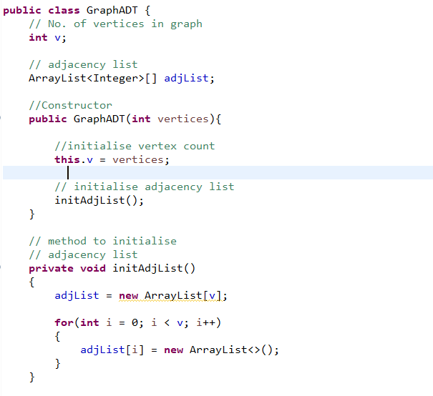Figure

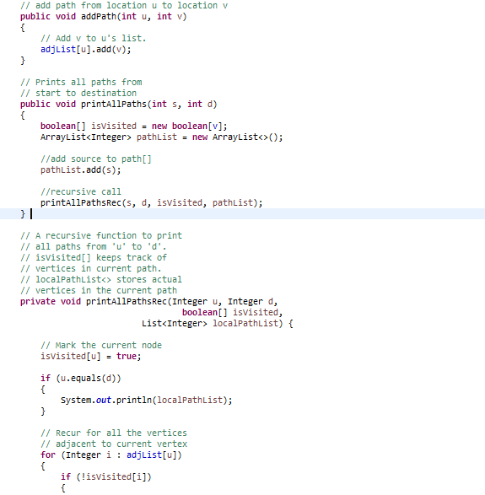

**Results**:

The adjacency lists are implemented using ArrayLists and as such the paths are displayed according to indices and the actual location names. The system thus helps tour guides know which routes to pass when carrying out tours. An improvement will be to have it displayed in a graphical user interface as well as have the times displayed which can be done for future work. A test case to check for the paths available from the Security Checkpoint to the Engineering building was used. The results are displayed in Figure 4 below.

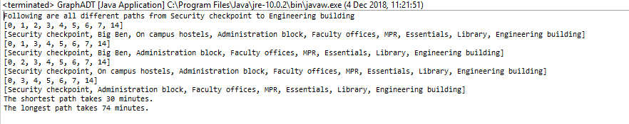

Figure

**Conclusion**

The graph data structure can be used to efficiently model path or road networks to help find the length for travelling along the path and can be used for transportation applications similar to Uber and also Google maps direction features.

**References**:

Graphs: Deﬁnition,Applications, Representation [PDF Document]. Retrieved from http://www.cs.cmu.edu/afs/cs/academic/class/15210-s14/www/lectures/graphs.pdf